Captioning Instructional Videos: Quick Reference
Subtitles and closed captions open your content to a larger audience, including viewers who are deaf or hard of hearing or those who speak languages besides the one spoken in your video. They also are greatly beneficial for language learners (e.g. English language learners) and improve comprehension and retention for everyone (Gernsbacher, 2015).
The easiest way to caption any video you create for your classes starts with uploading your video file to YouTube. YouTube is a video hosting service provided by Google.

Sign in and Access YouTube
- Navigate to the YouTube Website (www.YouTube.com)
- Sign in using your UTK NetID and Password
NOTE: All University Faculty, Staff and Students have access to Google accounts. If you aren’t signed in, sign in with the blue “Sign In” button toward the top-right corner. If you are signed in with a non-UT account, you may wish to “switch accounts” or sign out and sign in with your UT NetID.

1. Upload a Video
- Click the Upload button () in the upper right corner of YouTube.
  - If this your first time uploading with this account, it will prompt you to enter your name and “Create Channel.”
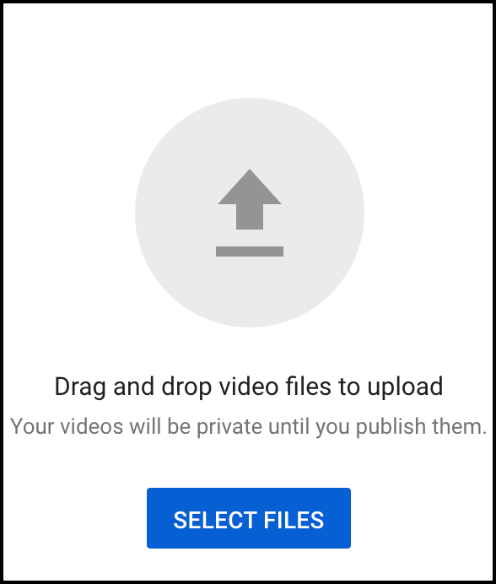
- The video privacy settings are set to Private until published, when the default is set to Public. We recommend “Unlisted.” This can be changed later in “YouTube Studio”.
  - Public videos and playlists can be seen by and shared with anyone. They can be found by searching YouTube or Google.
  - Private videos and playlists can only be seen by you and the users you choose. Individual must be invited to view.
  - Unlisted videos and playlists can be seen and shared by anyone with the link. Individuals must have the link to view.
- Select or drag and drop the video file you'd like to upload from your computer.

2. Access the Caption Interface
After your video has finished uploading…
- Click on your profile picture or icon in the top-right of the YouTube website.
- Click on “YouTube Studio”
- On the left-hand menu, click “Subtitles.”
- If prompted, set language to the spoken or signed language of the video.
  - If English, we recommend “English” rather than “English (United States)” etc.
  - Feel free to check the box to set this language to default for future uploads.
From this point, you will need to decide how you wish to caption the video. Two options and different steps are presented below. They continue from this point.

3a. Auto-Caption & Edit
YouTube automatically creates captions. These have improved substantially in accuracy over the years. However, you must always review and edit the captions. To use this option, you must wait for YouTube to complete its auto-captioning of your video. This may be a few minutes to several hours depending on the length of your video and other factors. Depending on the speaker’s accent or audio quality, auto captions may not be possible. Automatic captions are available in English, Dutch, French, German, Italian, Japanese, Korean, Portuguese, Russian, and Spanish. When it is done, it will show up as “English (Automatic)” in the video transcriptions page.
- In the “YouTube Studio,” navigate to “Subtitles” in the menu on the left side of the screen.
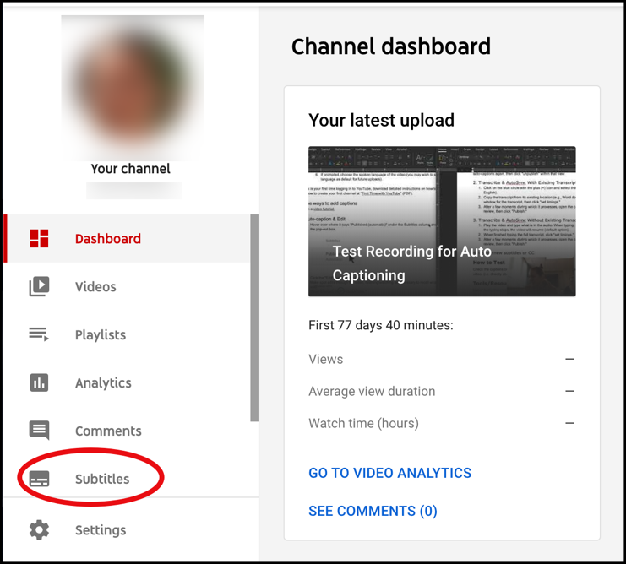
- Locate the video and click on the down arrow to reveal the captions.
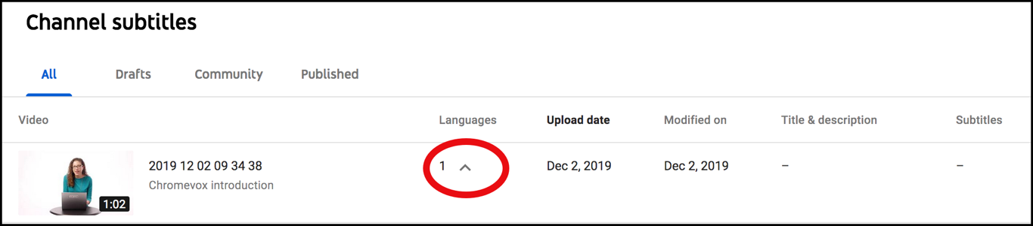
- Review automatic captions by selecting “Published” under the Subtitles column.
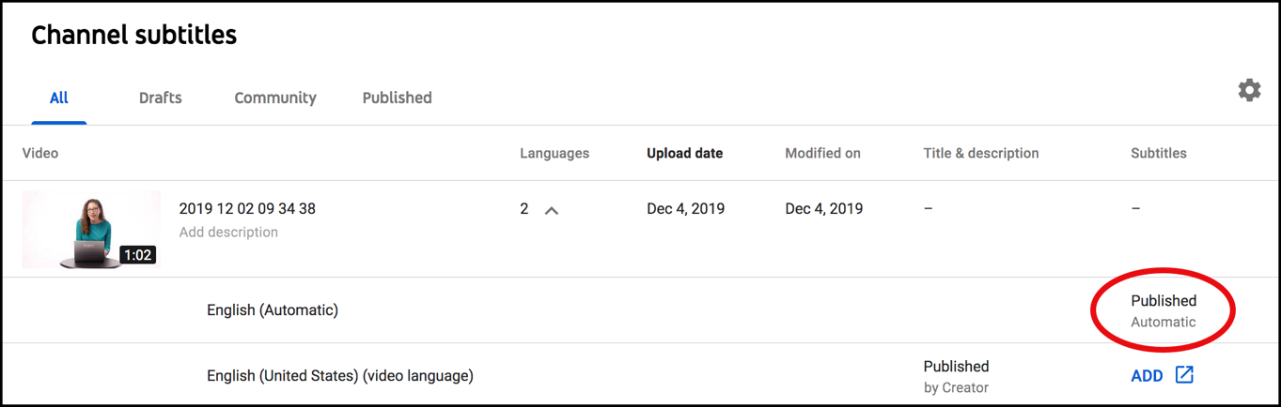
- Click the "Edit" button to the top-right of the screen.
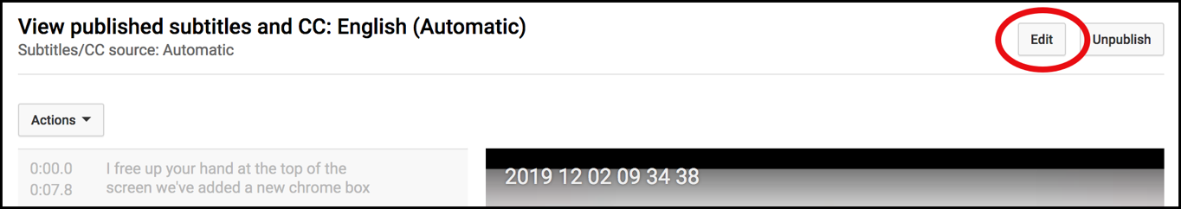
- Make spot edits through the video, listening/watching as necessary to recall what was said.
    - Add capitalization and punctuation.
    - When finished, click "Save changes."
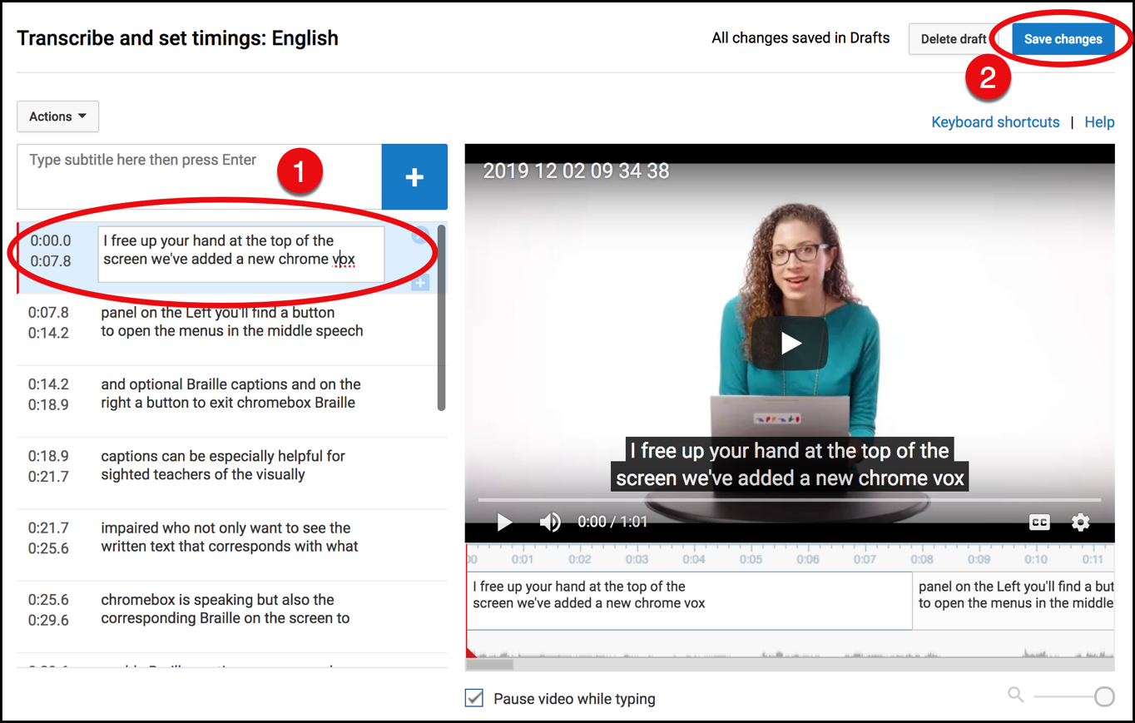
*Note that both the automatic and edited captions will now be published. If desired, "edit" the auto-captions again, then click "unpublish" within that view.
- If needed, adjust the timing of the transcript to match the audio with the video by clicking, holding, and dragging the blue handles to shorten or lengthen the time. Click, hold and drag from the middle to move entire block.
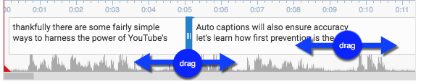
- Once editing is complete, click “Publish edits.” Make sure there is a green dot next to the captions labeled “English.”
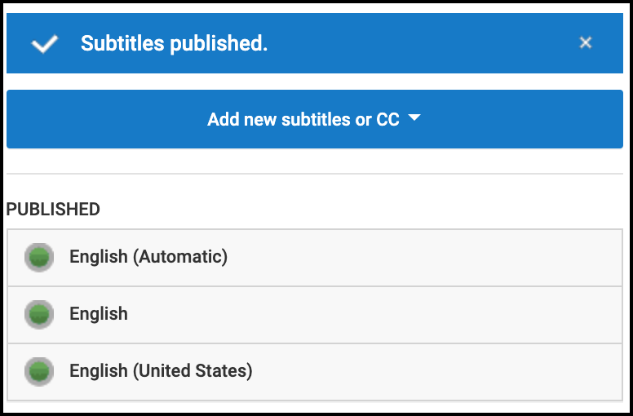
- The edited transcript will override the automatic captions as the default captions when the video is viewed with closed captions enabled.

3b. Transcribe & Auto-sync
If you already have a transcript for your video outside of YouTube, you can upload the file to create captions. This is the fastest way to provide accurate captions. From the video transcription page where you left off after part 2…
- Click the blue button to “Add new subtitles or CC.” If “English” isn’t available, you can either unpublish and delete the automatic captions or simply choose an English variant (e.g. “English (United States)”.
- Click the “Add” link in the subtitles column for the new language.
- Click on “Transcribe and auto-sync”.
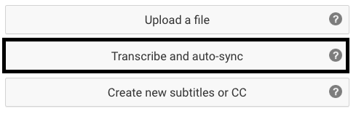
- Copy/Paste the transcript from the document that matches the audio.
- Click “Set Timing.”
- After a few moments during which it processes, open the captions (under "My Drafts").
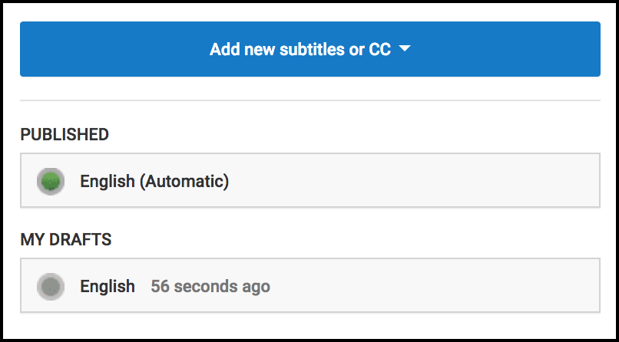
- Review and edit transcript, if necessary, by typing in the transcript window, then click "Publish."
- These captions will override the automatic captions when the video is viewed with closed captions enabled.

