Captioning Instructional Videos: Quick Reference
Subtitles and closed captions open your content to a larger audience, including viewers who are deaf or hard of hearing or those who speak languages besides the one spoken in your video. They also are greatly beneficial for language learners (e.g. English language learners) and improve comprehension and retention for everyone (Gernsbacher, 2015).
The easiest way to caption any video you create for your classes starts with uploading your video file to YouTube. YouTube is a video hosting service provided by Google.

Sign in and Access YouTube
- Navigate to the YouTube Website (www.YouTube.com)
- Sign in using your UTK NetID and Password
- Click on your profile picture in the top right corner to open the dropdown menu and select YouTube Studio.
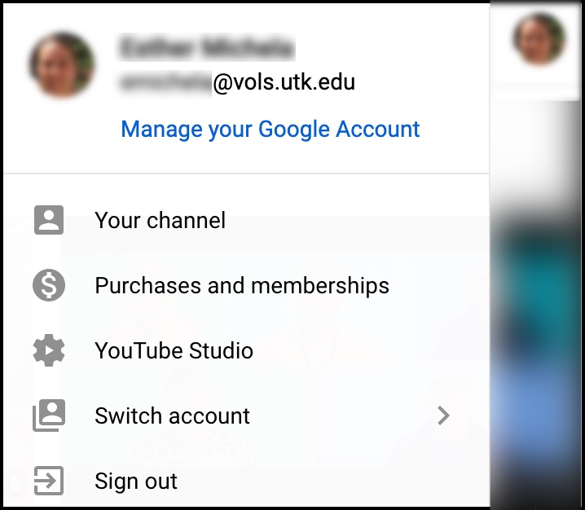
NOTE: All University Faculty, Staff and Students have access to Google accounts. If you aren’t signed in, sign in with the blue “Sign In” button toward the top-right corner. If you are signed in with a non-UT account, you may wish to “switch accounts” or sign out and sign in with your UT NetID.

1. Upload a Video
- Click the Create () or Upload ( ) button in the upper right corner of the window.
  - (Note If this your first time uploading with this account, it will prompt you to enter your name and “Create Channel.”)
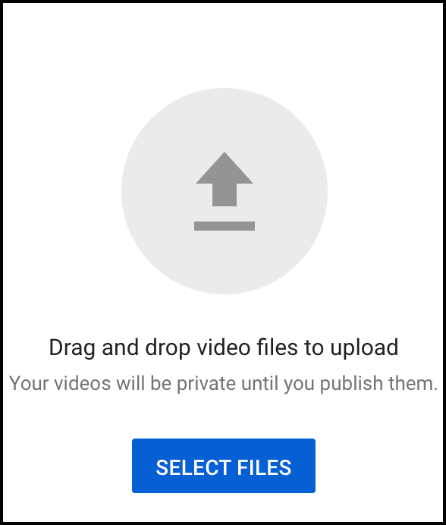
- Select or drag and drop the video file you'd like to upload from your computer.
- As the file is processing, you will go through three segments determine video elements.
- In the Details section, you can add a title and description, select or upload a thumbnail, select the audience, set the video license, add tags, select the language, upload a closed captions file, select a category, and set preferences for comments.
- In Video elements, you may be able to add an end screen or promotional cards.
- In Visibility, you can set video privacy settings. We recommend “Unlisted.” This can be changed later in “YouTube Studio”.
  - Public videos and playlists can be seen by and shared with anyone. They can be found by searching YouTube or Google.
  - Private videos and playlists can only be seen by you and the users you choose. Individual must be invited to view.
  - Unlisted videos and playlists can be seen and shared by anyone with the link. Individuals must have the link to view.
- Select Save to finish the upload.

2. Access the Caption Interface
After your video has finished uploading and processing…
- Click on your profile picture or icon in the top-right of the YouTube website.
- Click on YouTube Studio.
- On the left-hand menu, click Subtitles ().
From this point, you will need to decide how you wish to caption the video. Two options with different steps are presented below. They continue from this point.

3a. Auto-Caption & Edit
YouTube automatically creates captions. These have improved substantially in accuracy over the years. However, you must always review and edit the captions. To use this option, you must wait for YouTube to complete its auto-captioning of your video. This may be a few minutes to several hours depending on the length of your video and other factors. We recommend waiting and using this option if you do not have a script or captions file. Depending on the speaker’s accent or audio quality, auto captions may not be possible. Automatic captions are available in English, Dutch, French, German, Italian, Japanese, Korean, Portuguese, Russian, and Spanish. When it is done, it will show up as “English (Automatic)” in the video transcriptions page.
- In the YouTube Studio, navigate to Subtitles in the menu on the left side of the screen.
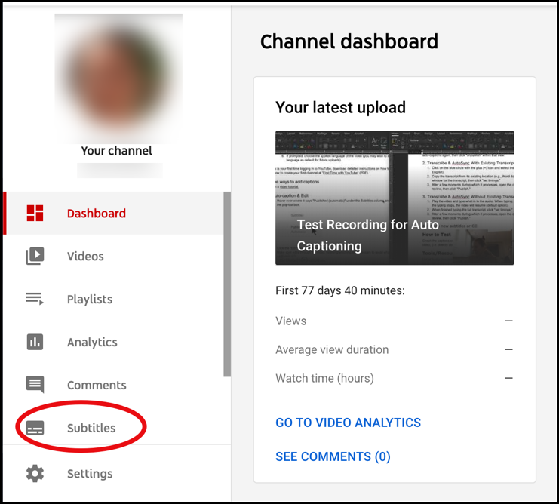
- Locate the video and click on the caret in the languages column to reveal the captions.
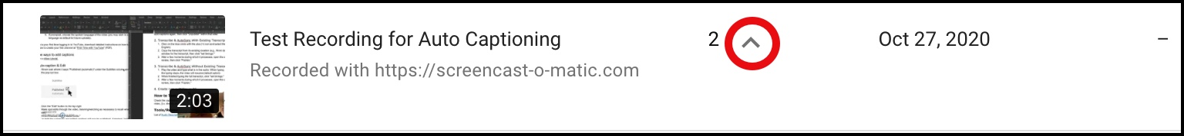
- Review automatic captions by selecting Duplicate and Edit under the Subtitles column.
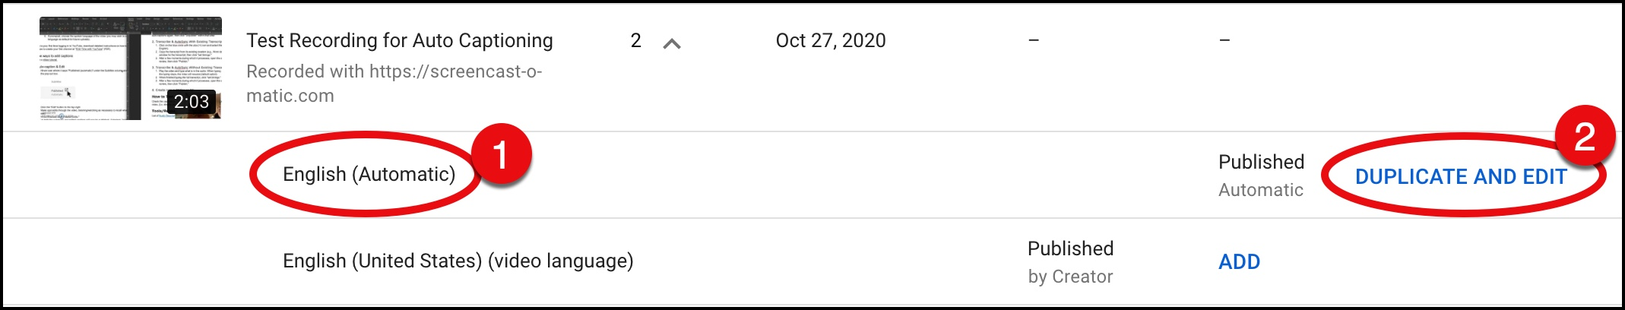
- Click the Assign timings button to automatically align the words and audio.
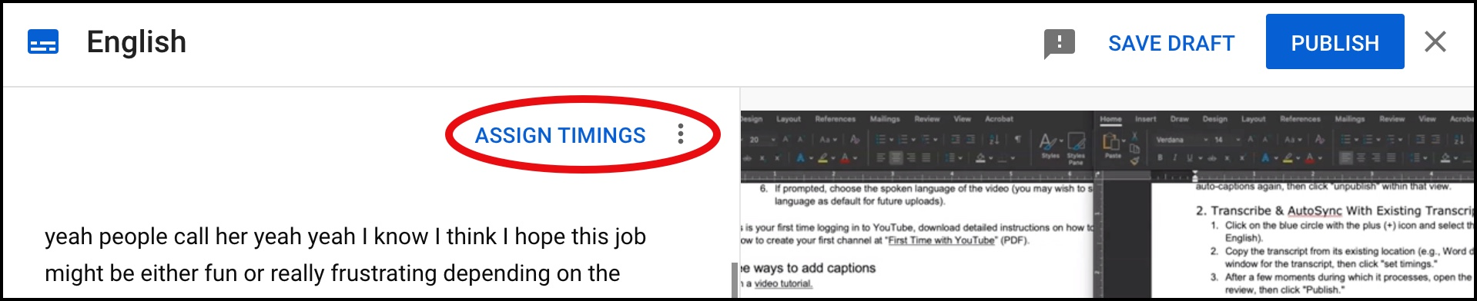
- Make spot edits through the video, listening/watching as necessary to recall what was said.
    - Add capitalization and punctuation.
    - When finished, click the Publish button.
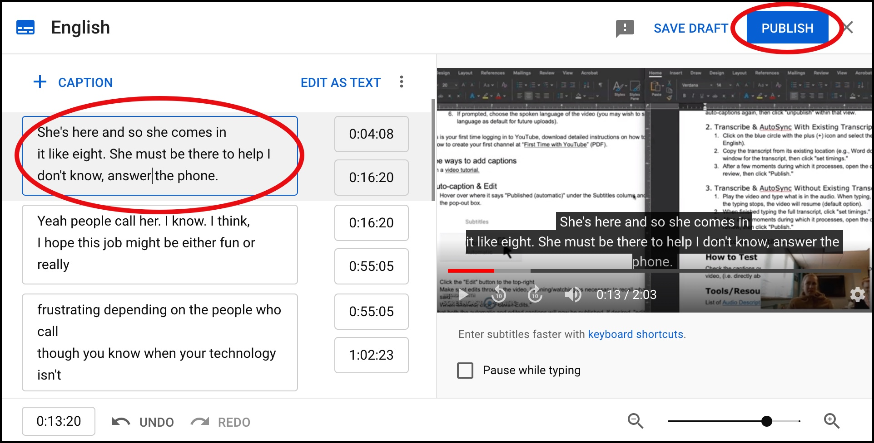
*Note that both the automatic and edited captions will now be published. If desired, "edit" the auto-captions again, then click "unpublish" within that view.
- If needed, adjust the timing of the transcript to match the audio with the video by clicking, holding, and dragging the edges of the text to shorten or lengthen the time. Click, hold and drag from the middle to move entire block.
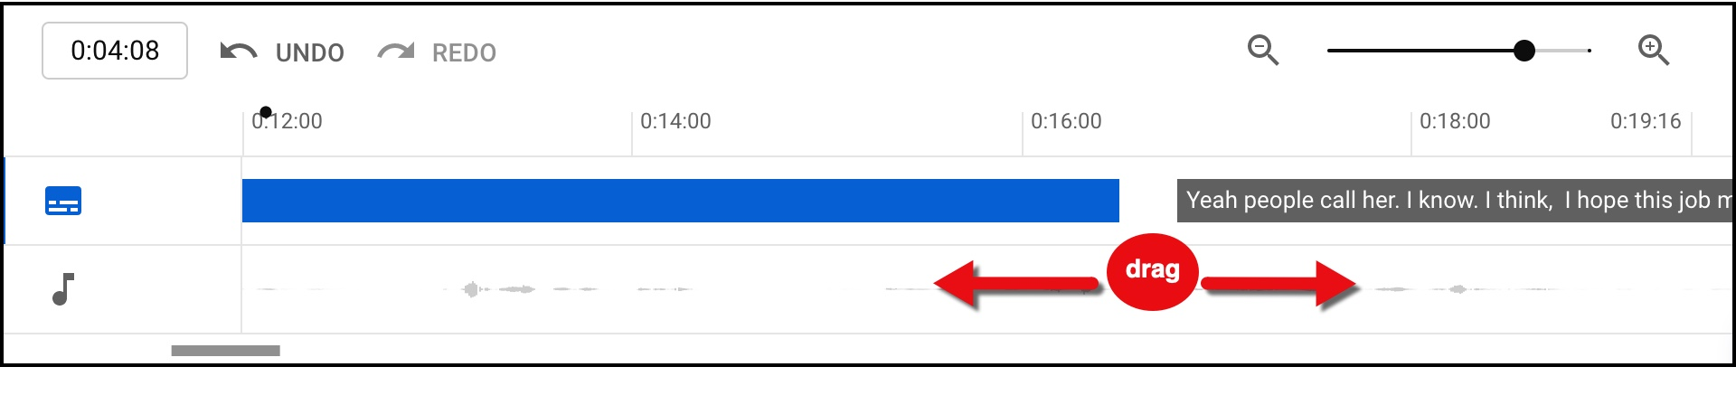
- Once editing is complete, click Publish.
- The edited transcript will override the automatic captions as the default captions when the video is viewed with closed captions enabled.

3b. Upload a File
There are several other methods of adding your own closed captions. If you already have a properly formatted captions file for your video outside of YouTube, you can upload the file to create captions. This is the fastest way to provide accurate captions. From the video transcription page where you left off after part 2…
- Click on ADD in the subtitles column.
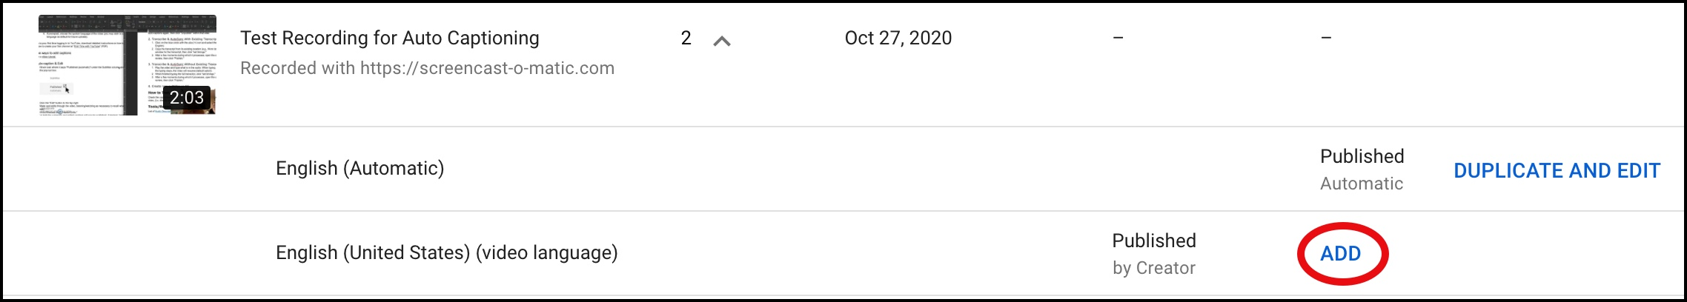
- Click on Upload file.
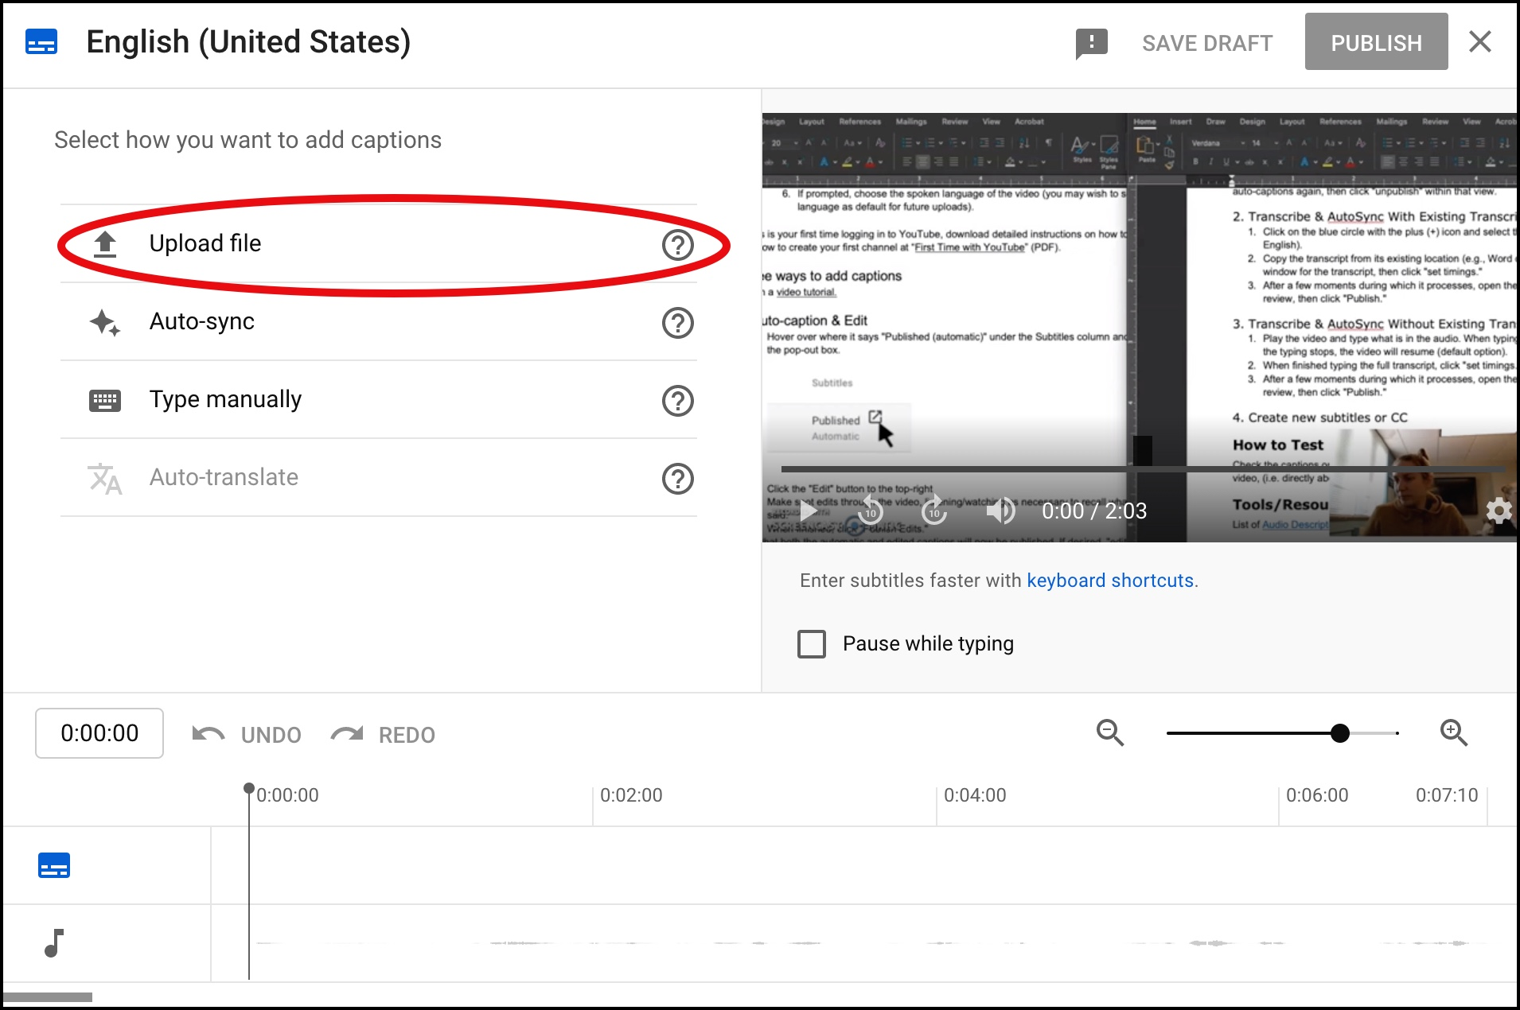
- Select the subtitle file type and click Continue to upload your file.
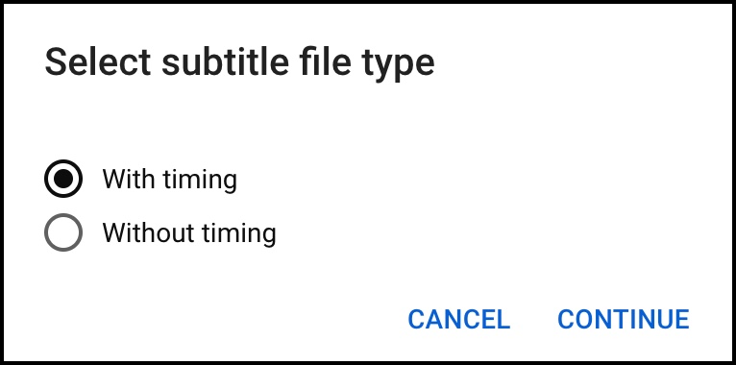

3c. Auto-sync
Use this option if you have a script or transcript of the audio.
- Click on Auto-sync.
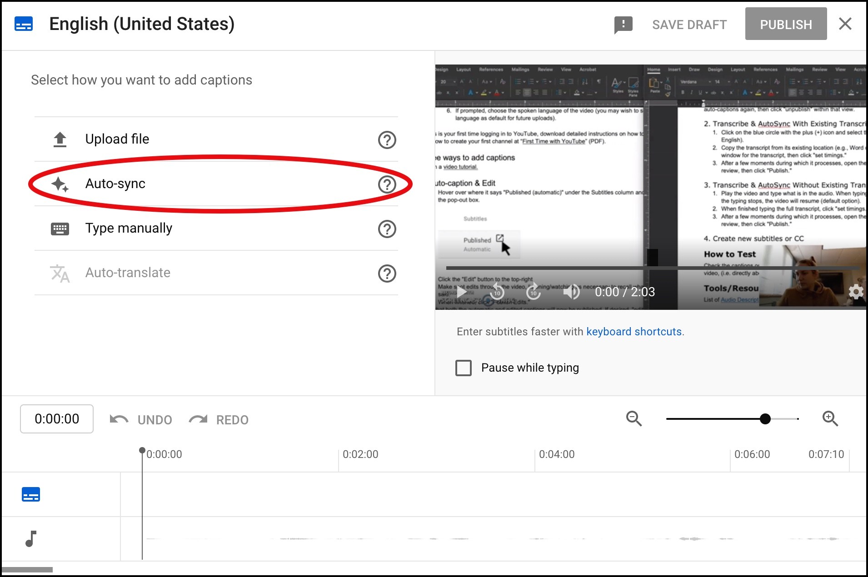
- Copy/Paste the transcript from the script or transcript (without any timing numbers).
- Click Assign Timing.
- Review and edit transcript, if necessary, by typing in the transcript window, then click Publish.
- These captions will override the automatic captions when the video is viewed with closed captions enabled

3d. Type Manually
We don’t recommend typing out the transcript by hand since YouTube will automatically create captions for you. However, if you have a short video and want to type them out quickly…
- Click on Type manually.
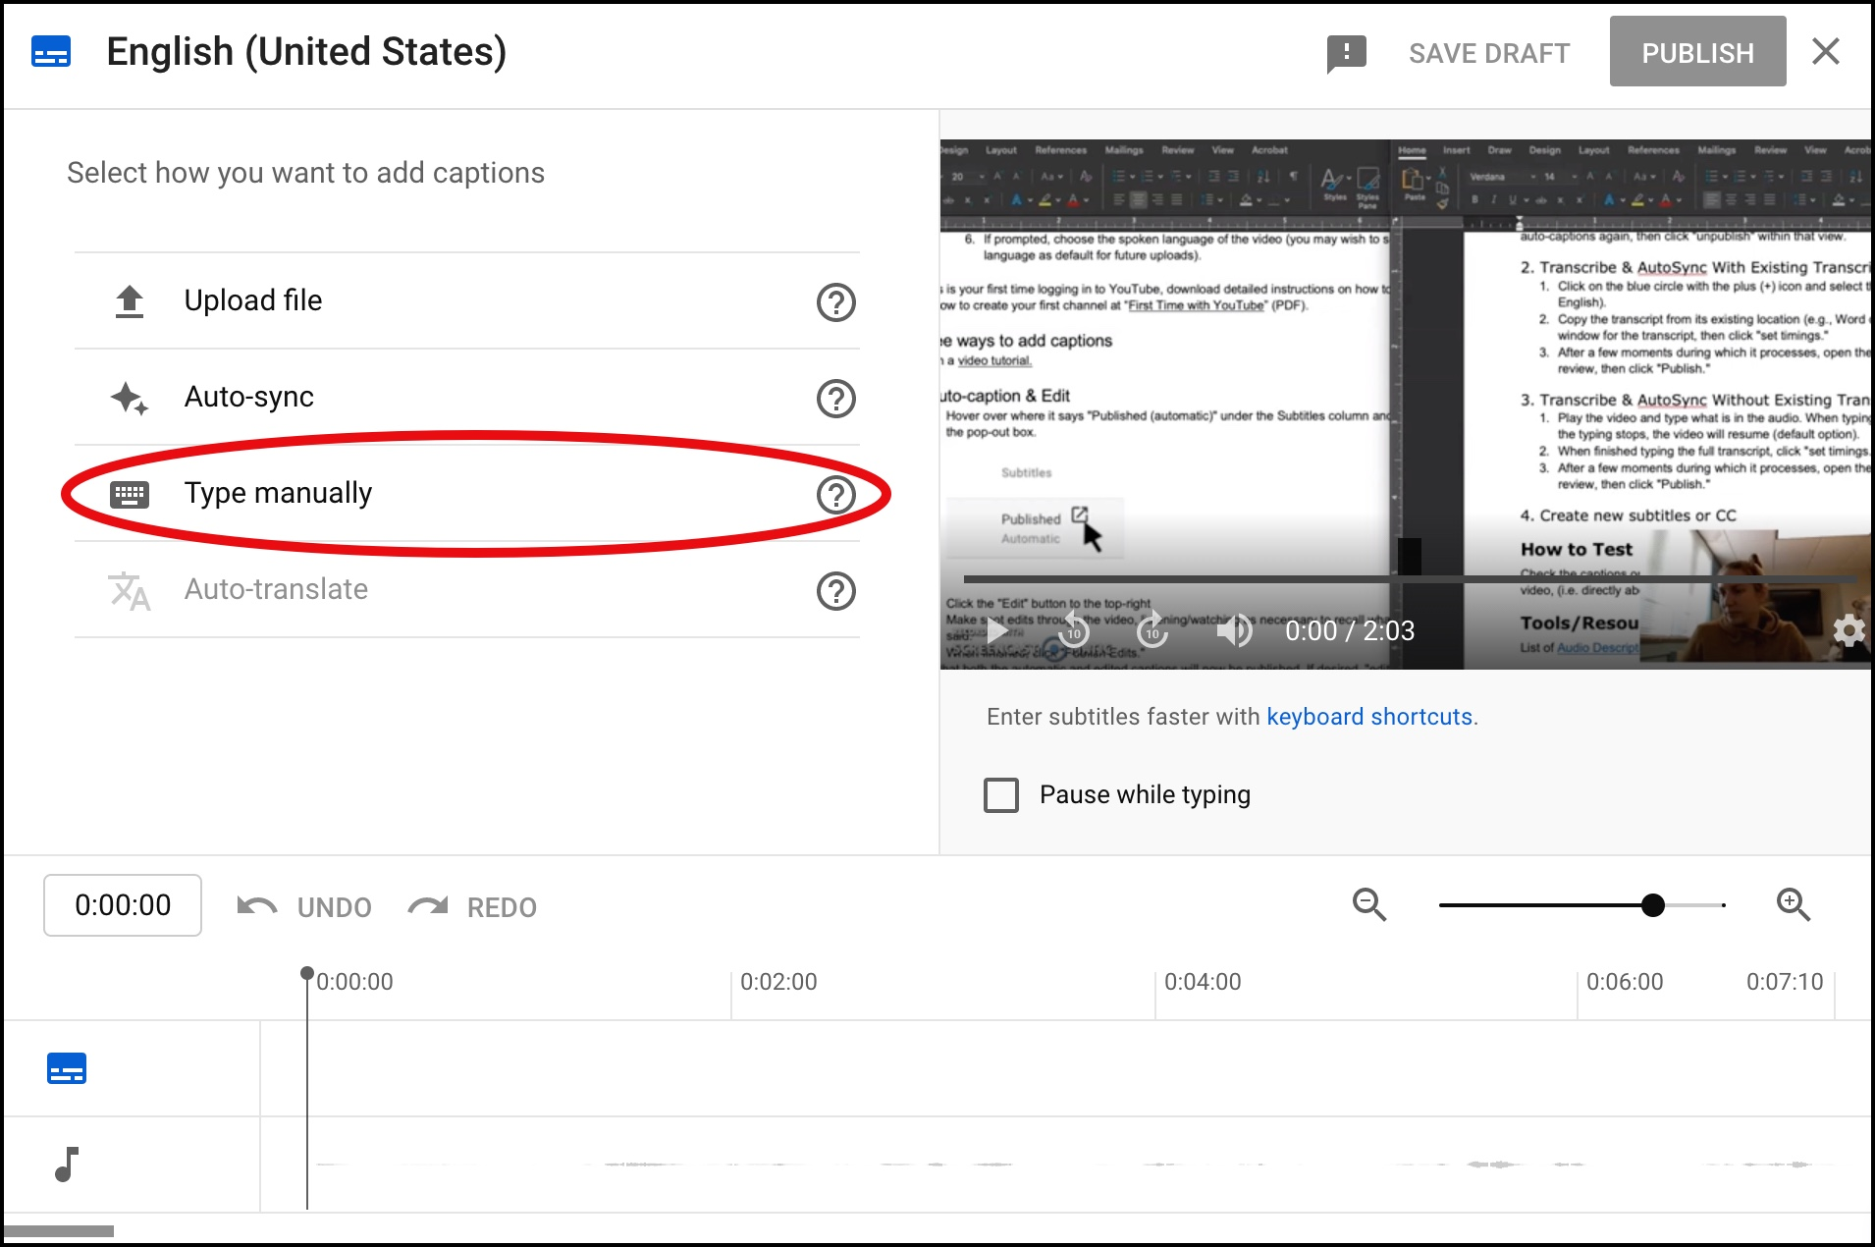
- Type the captions and click on + Caption to add a new caption section.
- Click on EDIT AS TEXT to type the captions as one long text and Assign Timings at the end.
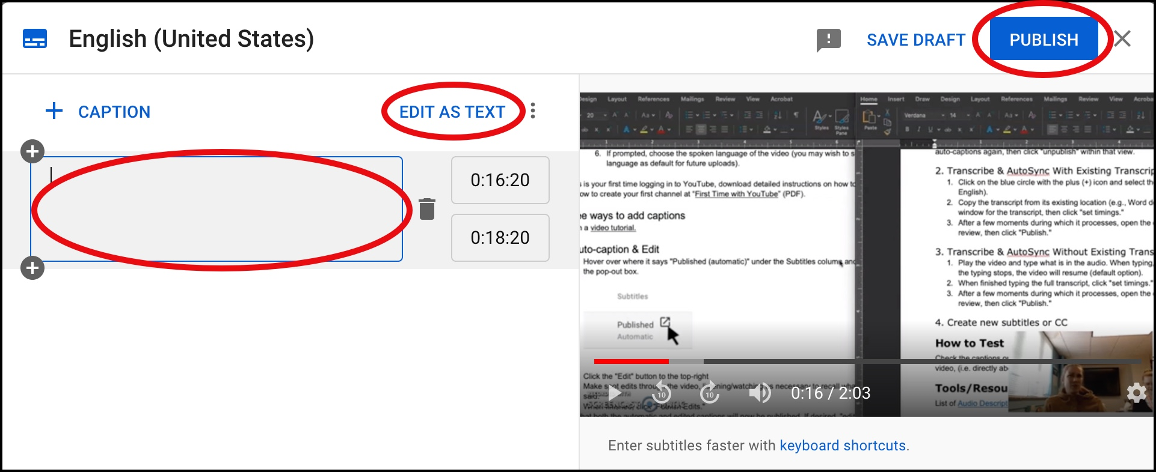
- Click Publish when you are finished.

