Captioning Instructional Videos: Quick Reference

Subtitles and closed captions open your content to a larger audience, including viewers who are deaf or hard of hearing or those who speak languages besides the one spoken in your video. They also are greatly beneficial for language learners (e.g. English language learners) and improve comprehension and retention for everyone (Gernsbacher, 2015).
The easiest way to caption any video you create for your classes starts with uploading your video file to YouTube. YouTube is a video hosting service provided by Google.

Sign in and Access YouTube
- Navigate to the YouTube Website (www.YouTube.com)
- Sign in using your UTK NetID and Password
NOTE: All University Faculty, Staff and Students have access to Google accounts. If you aren’t signed in, sign in with the blue “Sign In” button toward the top-right corner. If you are signed in with a non-UT account, you may wish to “switch accounts” or sign out and sign in with your UT NetID.

Upload a Video
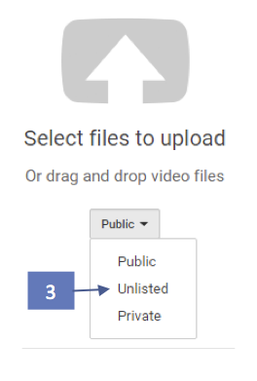
- Click the Upload button in the upper right corner of YouTube.
  - If this your first time uploading with this account, it will prompt you to enter your name and “Create Channel.”
- Choose the video privacy settings. The default is set to Public. We recommend “Unlisted.” This can be changed later in Video Manager.
  - Public videos and playlists can be seen by and shared with anyone. They can be found by searching YouTube.
  - Private videos and playlists can only be seen by you and the users you choose. Individual must be invited to view.
  - Unlisted videos and playlists can be seen and shared by anyone with the link. Individuals must have the link to view.
- Select the video you'd like to upload from your computer.
- If you set the video privacy to “Unlisted,” just click Done to finish the upload.
- To caption the uploaded video, click on “Video Manager” to the bottom left of the video and skip to step 4 in either Option 1 or 2. Select “Subtitles and CC” in the top-right of that screen.

Option 1: Auto-Caption & Edit
YouTube automatically creates captions. These have improved substantially in accuracy over the years. However, you must always review and edit the captions.

Edit the Captions on your Videos
- Navigate to YouTube and sign in to your account by clicking “sign in” in top-right corner (unless already signed in).
- Once your videos are uploaded to YouTube, you may edit them in the Video Manager (https://www.youtube.com/my_videos). Go there.
- Locate your video in the list.
- To edit captions or subtitles, click the drop-down menu (▼) next to the Edit button, to the right of the desired video and click “Subtitles/CC.”
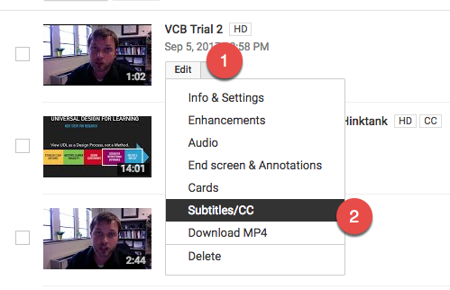
- A “set video language” dialogue box is displayed if this is the first time editing the video. Select “English” (or whatever the language of the spoken word is in the video).
- A dialogue box will open asking to set the video language. Click “Select Language” and choose English (or start typing the primary language of the video and select that).
- To the right of the video, a button should appear with “English (Automatic)”. If this doesn’t appear, it may need more time to generate. How long that takes depends on the size of the video (ranges from minutes to hours). Click this button.
- Click the “Edit” button to the top right of the video.
- Click where you want to make changes and edit the text. Type in changes, and use the “enter” key to create caption breaks.
- If needed, adjust the timing of the transcript to match the audio with the video by clicking, holding, and draging the blue handles to shorten or lengthen the time. Click, hold and drag from the middle to move entire block.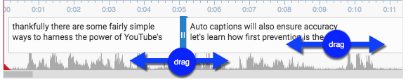
- Once editing is complete, click “Save Changes.” Make sure there is a green dot next to the captions labeled “English.”
- The edited transcript will override the automatic captions when the video is viewed with closed captions enabled.

Option 2: Transcribe & Auto-sync
If you already have a transcript for your video outside of YouTube, you can upload the file to create captions. This is the fastest way to provide accurate captions.
- Navigate to YouTube and sign in to your account by clicking “sign in” in top-right corner (unless already signed in).
- Once your videos are uploaded to YouTube, you may edit them in the Video Manager (https://www.youtube.com/my_videos). Go there.
- Locate your video in the list.
- To edit captions or subtitles, click the drop-down menu (▼) next to the Edit button, to the right of the desired video and click “Subtitles/CC.”
- A “set video language” dialogue box is displayed if this is the first time editing the video. Select “English” (or whatever the language of the spoken word is in the video).
- A dialogue box will open asking to set the video language. Click “Select Language” and choose English (or start typing the primary language of the video and select that).
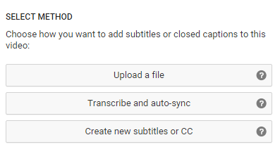
- Click the “Add new subtitles or CC” button to the right of the video.
- Choose the language spoken in the video.
- Select “Transcribe and auto-sync”.
- Copy/Paste the transcript that matches the audio.
- Click “Set Timing.”
- These captions will override the automatic captions when the video is viewed with closed captions enabled.

Other Options
Computer Software: AegiSub.org and Jubler.org provide computer software (Mac, Win) for more custom control and offline security in captioning videos. They are more labor intensive to use, however.
Professional Captioning: Paid professional captioning companies exist. We recommend:
- Cielo24
- CaptionSync

