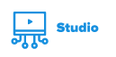
Captioning Canvas Studio Videos: Quick Reference
Subtitles and closed captions open your content to a larger audience, including viewers who are deaf or hard of hearing or those who speak languages besides the one spoken in your video. They also are greatly beneficial for language learners (e.g. English language learners) and improve comprehension and retention for everyone (Gernsbacher, 2015).
An easy and effective process to caption any video you create for your classes starts with uploading your video file to Canvas Studio on Canvas.

1. Sign in to Canvas
- Navigate to https://online.utk.edu/.
- Sign in to Canvas using your UTK NetID and Password

2. Upload a Video to Canvas Studio
- On the far left-hand menu, click on the Canvas Studio logo ().
- Click on the “Add” button located in the top-right () corner.
- Browse Files (blue button) and locate the file from your computer. *
*Note: you can use Canvas Studio with YouTube videos, but automatic captioning is not available if you do so.

3. Auto-caption and Edit
After your video has finished uploading and processing…
- Click on the video you wish to caption.
- Locate the “CC Captions” tab in the white window below the video.

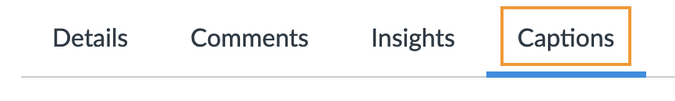

- Under “Captions Request” on the left side, select the spoken language of the video (Some languages are not available for captioning in Canvas Studio). Click Request.
- Canvas Studio will auto-generate captions. This can take several minutes to several hours depending on the length of your video and other factors. You can safely navigate away while this is working.
- When Canvas Studio is finished processing the automatic captions, click Review and Publish.

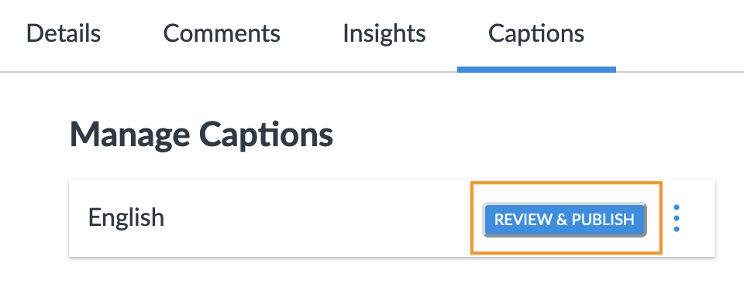

- Scan through the captions and make any edits necessary simply by clicking on the text and making changes.
- When finished, click the green Publish button to the top-right of the captions. Done!

FAQ:

Q: Can I adjust where the captions display on the screen?
A: No. Canvas Studio puts captions at the top of the viewing screen. At this time, there’s no way to change that.

Q: What else can I do with Canvas Studio?
A: Below are some of the main features in Canvas Studio:
- Record a screen capture (similar to the functionality of Jing, Screencast-O-Matic, Camtasia)
- Embed video directly into Canvas courses (Pages, Assignments, Discussions, Quizzes, Announcements)
- Faculty and students can add comments directly to the video and reply to other's comments
- Create Canvas Studio assignments where students use Canvas Studio to create and upload their own videos
- View video analytics (which students are watching your video and for how long!)

