Automatic Captions & Transcripts in Zoom: Quick Reference
Subtitles and closed captions open your content to a larger audience, including viewers who are deaf or hard of hearing or those who speak languages besides the one spoken in your video. They also are greatly beneficial for language learners (e.g., English language learners) and improve comprehension and retention for everyone (Gernsbacher, 2015).
Did you know you can use automatic captions (~85% accurate) in Zoom, for no extra cost? Here’s how. There is an automatic, real-time transcription that may be enabled by the instructor or meeting leader of a Zoom session. To engage this feature, please review the following.
- The leader/host must enable the Closed Captioning feature in their Zoom account settings to also enable the live transcription.
- The live transcription must be engaged in the meeting before the session begins.

First, to Enable Closed Captioning in Settings…

1. Log in to the Zoom Web Client.
- Navigate to Tennessee.zoom.us/
- Select "Create or Edit Account" to login with a NetID and password.

2. Adjust your settings to enable live captions for all meetings you host.
- Choose “Settings” on the menu on the left.
- Scroll down to the section headed “Closed Captioning”
- Toggle on the switch next to “Closed captioning.”
- Check the box "Enable live transcription service to show transcript in the side panel in-meeting"
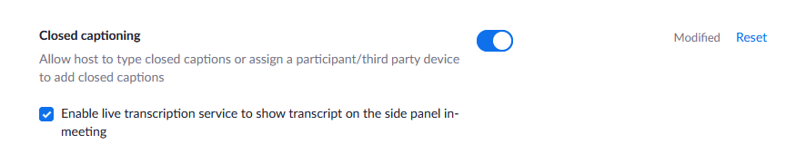
This activates the functionality for automatic live captions and transcripts for all meetings hosted by the account in which this feature is activated. However, the feature must be turned on in each meeting, too (next step).

Second, Turn on Captions and Transcripts in your Meeting…

1. Activate Live Captions and Transcription
- (Note: Only hosts can see this until they are turned on.)
- Select the “CC Live Transcript” button.
- Select “Enable Auto-Transcription” at the bottom of the menu that pops up.
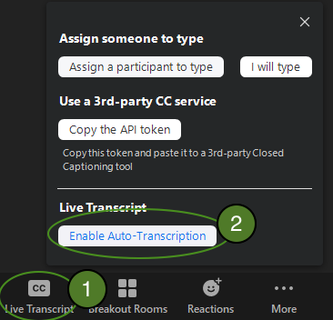

Note that end user will now see the “CC Live transcript” button, themselves, and can use this to:
- toggle the captions off and on
- display a live transcript
End users may also move the caption display around if it blocks visibility of any content (It is a “floating” window).

